Name of the Student Chapter
Central Michigan University American Institute of Professional Geologists Student Chapter
Names of Student Chapter Officers
President: Lauren Galien
Vice President: Jacob Zieziul
Secretary: Emily Yoder
Treasurer: Grace Borst
Publicity Chair: Victoria Konieczka
Names of Student Chapters Officers for the Following Academic Year
President: Emily Yoder
Vice President: Abigail Russelburg
Secretary: Peter Smith
Treasurer: Grace Borst
Publicity Chair: Victoria Konieczka
Number of AIPG Student Members in the Chapter
We have 25 members in our chapter, but only about 12 are most involved with AIPG.
Number of Chapter Meetings
We met weekly to biweekly and had some weeks off for wellness days. In total, we had about 28 meetings.
Recruitment
In order to recruit new members, we post flyers advertising our meetings, as long as putting our information in the university’s e-newsletter. We present at department meetings and speak to geology classes. We have also been holding informal meetings off of campus, like hikes, that are open to friends of aipg members.
Fundraising
Fundraising was limited this year. We were not allowed on campus in any nonacademic capacity, so we could not do our rock sales. However, we were able to sell some rocks and minerals to club members along with old CMU AIPG merchandise. We are super excited to get back to our normal fundraising for next year!
Activities:
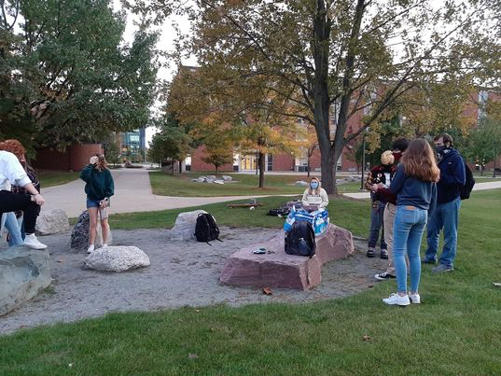
Our outdoor meetings! By the rocks!
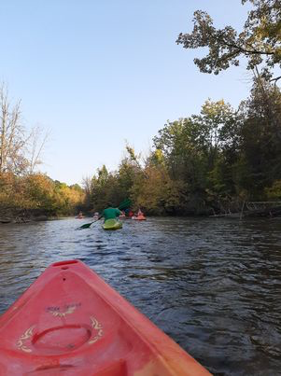
Kayaking Social Event
Our activities were limited this year due to current circumstances, but we were able to hold meetings outside (with masks) when the weather was nice and on Webex when the weather was less nice. We were able to hold a few social events including hikes and kayaking. Within the department, we were able to attend the seminars presented by faculty visiting virtually. We also competed in our annual faculty vs. student food drive for the Mount Pleasant community. We were able to attend some of the virtual meetings held by Michigan AIPG and EMU where professional geologists presented their work. We also were able to attend the Michigan section meeting virtually. We continued to hold our geology tutoring for students in Introductory Geology, which is a great opportunity for recruitment, as well as giving back to the department.

